Task: Programming Assignment Console Apps

Prob 1 Screenshot:

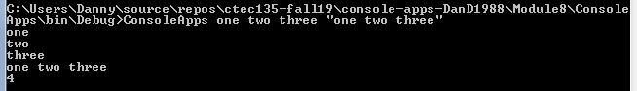

Prob 2 ScreenShot: Didn’t work

